SOFTWARE ENGINEERING | COMSATS UNIVERSITY ISLAMABAD, VEHARI CAMPUS
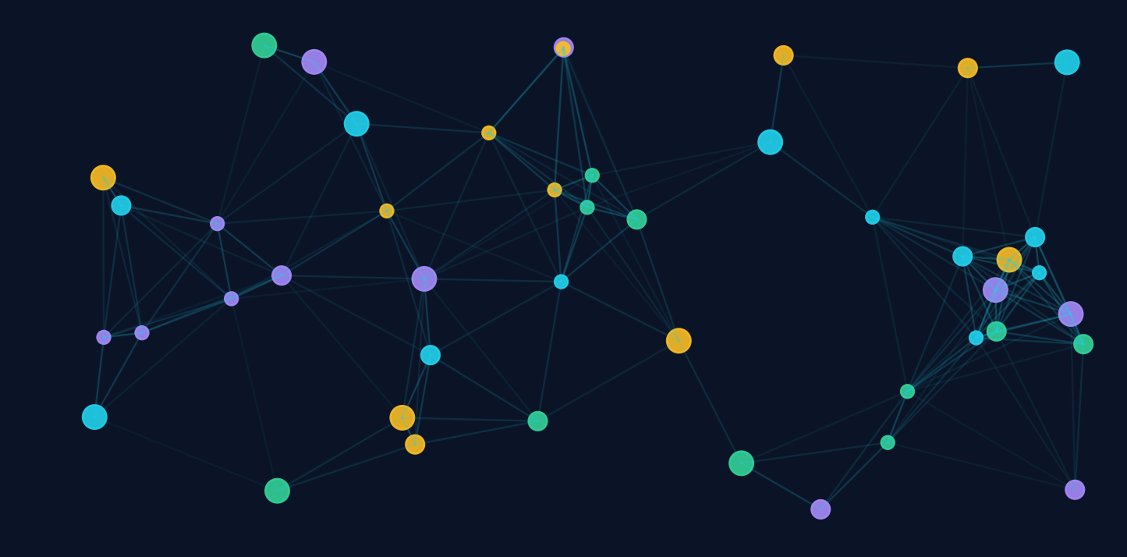
PARALLEL &
DISTRIBUTED COMPUTING
Working, Examples, Pros & Cons and Real-World Systems such as Netflix
Submitted by | Muhammad Ahmad Mujtaba
Registration No. | FA23-BSE-041
Program | BS Software Engineering
Topic | Parallel & Distributed Computing

Contents
No. | Section | What it covers
1 | Introduction | Parallel vs distributed computing, key differences
2 | Parallel Computing | How it works, types, Amdahl's Law, examples, pros and cons
3 | Distributed Computing | How it works, architectures, core concepts, pros and cons
4 | Real-Life Distributed Systems | Netflix case study, Google, Amazon, YouTube and more
5 | Comparison and When to Use Each | Decision table, hybrid systems, shared challenges
6 | Conclusion and References | Summary and sources

List of Figures
- Figure 1: Parallel vs distributed architecture
- Figure 2: Divide, process in parallel, combine
- Figure 3: Speedup limits according to Amdahl's Law
- Figure 4: Common distributed architecture models
- Figure 5: Simplified Netflix architecture

1. Introduction
Modern software rarely runs on a single processor doing one thing at a time. Problems such as weather forecasting, training AI models, streaming video to millions of viewers and processing bank transactions are far too large for one sequential program. Two ideas make them possible: parallel computing and distributed computing.

1.1 Parallel Computing
Parallel computing means breaking one problem into smaller parts and solving those parts at the same time using multiple processing units (CPU cores, GPU cores or processors) that usually sit inside one machine and share memory. The goal is speed: finish a single job faster.

1.2 Distributed Computing
Distributed computing means a group of independent computers, connected by a network, that cooperate to look like one system to the user. Each machine has its own memory and they coordinate by sending messages. The goals are scalability, availability and resource sharing, not only speed.
Simple way to remember: parallel = many workers in ONE kitchen sharing the same fridge. Distributed = many kitchens in DIFFERENT cities that talk on the phone.

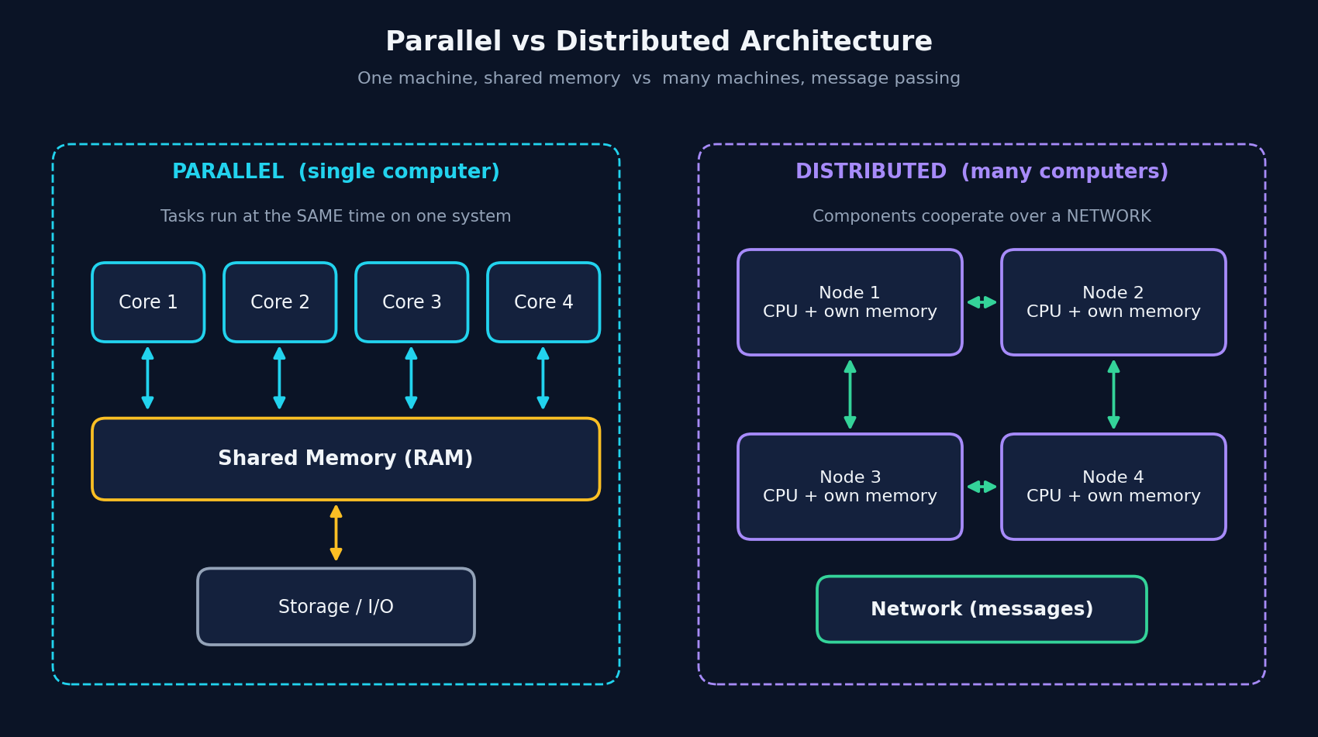
Figure 1: Parallel vs distributed architecture

1.3 Key Differences
Aspect | Parallel Computing | Distributed Computing
Machines | One computer, many cores/processors | Many independent computers
Memory | Usually shared memory | Each node has private memory
Communication | Very fast (memory bus, shared variables) | Slower (network messages)
Main goal | Reduce execution time (performance) | Scalability, availability, resource sharing
Failure handling | Whole machine usually fails together | Partial failure is normal and must be handled
Coordination | Locks, barriers, threads | Consensus, replication, message queues
Examples | GPU rendering, multicore matrix multiplication | Netflix, Google Search, blockchain, cloud

2. Parallel Computing

2.1 How It Works
A parallel program follows a repeating pattern. Its steps are:
- Decomposition: The problem is divided into independent sub-tasks.
- Assignment: Each sub-task is given to a core, thread or processor.
- Execution: All units run their sub-tasks at the same time.
- Synchronization: Threads exchange data or wait for each other using locks, semaphores or barriers so results stay correct.
- Combination: Partial results are merged into the final answer.
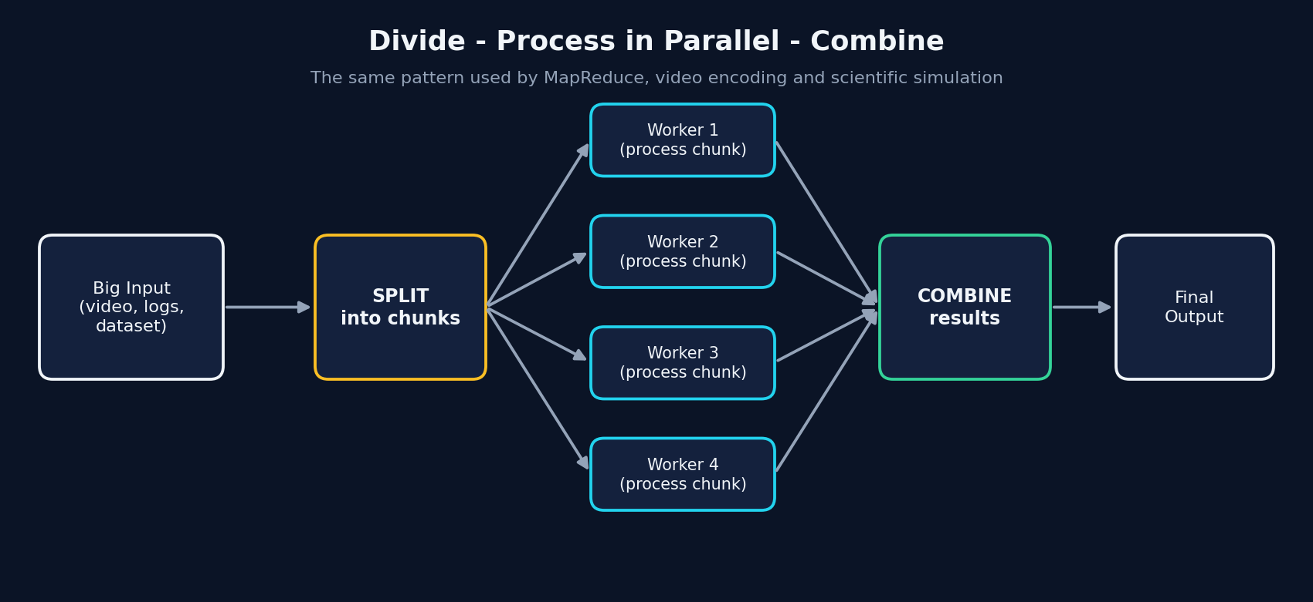
Figure 2: Divide, process in parallel, combine

2.2 Types of Parallelism
Type | Idea | Example
Bit-level | Wider processor words handle more bits per instruction | 64-bit CPUs adding large numbers in one step
Instruction-level | CPU overlaps instructions (pipelining, superscalar) | Modern CPU pipeline
Data parallelism | Same operation on different pieces of data (SIMD) | GPU applying a filter to every pixel
Task parallelism | Different tasks run at the same time (MIMD) | One thread renders UI while another downloads

2.3 Memory Models
- Shared memory: all processors access one common memory (multicore CPUs, OpenMP, Java threads). Easy to program, but needs careful locking.
- Distributed memory: each processor has its own memory and communicates by message passing (MPI). Scales further but is harder to program.
- Hybrid: a mix, such as a cluster of multicore machines each with GPUs. Most supercomputers work this way.

2.4 Amdahl's Law
Not every program can be fully parallelised. Amdahl's Law says speedup = 1 / ((1 - P) + P / N), where P is the parallel fraction of the program and N is the number of processors. If 10% of a program must run serially, no number of processors can make it more than 10 times faster.
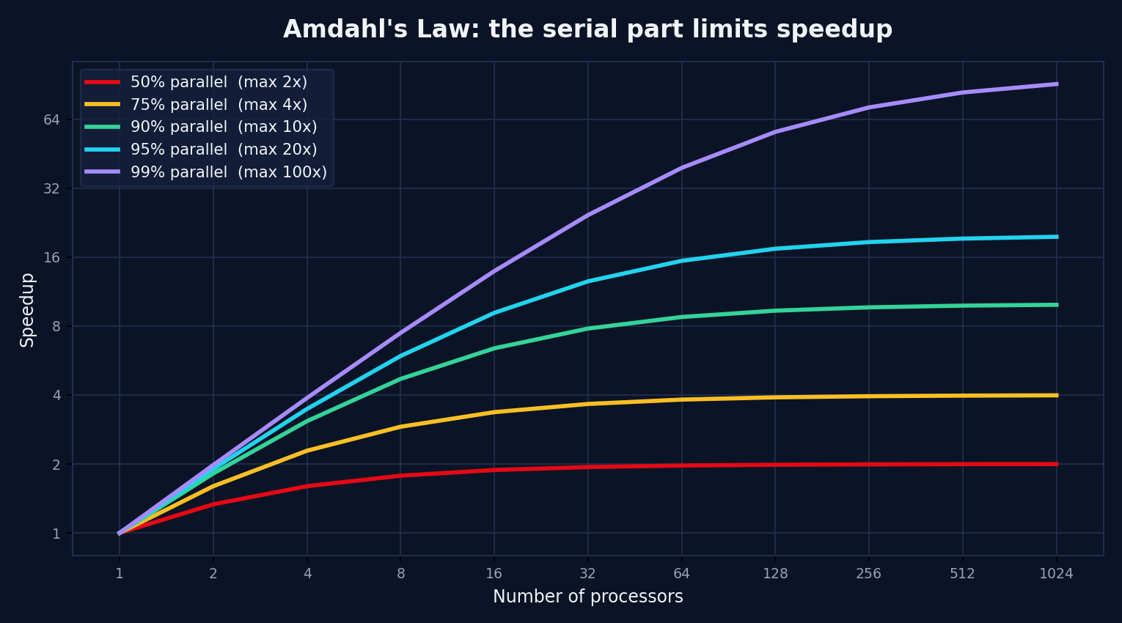
Figure 3: Speedup limits according to Amdahl's Law

2.5 Real-Life Examples of Parallel Computing
Example | How parallelism is used
Multicore smartphones and laptops | Different cores run the app, the browser and background services at once; the OS scheduler spreads threads across cores.
GPUs in gaming and graphics | Thousands of small cores compute the colour of millions of pixels simultaneously every frame.
Deep learning (e.g. training neural networks) | Matrix operations are split across GPU cores; large models are split across many GPUs.
Weather forecasting and climate models | The atmosphere is divided into a 3D grid; each processor simulates one region and exchanges boundary values.
Video editing and rendering | Frames or blocks of a frame are rendered by different cores at the same time.
Scientific simulations (protein folding, physics) | Supercomputers run millions of independent calculations in parallel.

2.6 Advantages and Disadvantages
Advantages | Disadvantages
- Much faster execution of large computations  - Better use of modern multicore hardware  - Handles problems too large for one sequential program  - Efficient communication because memory is shared  - Higher throughput for many independent tasks | - Hard to design, debug and test (race conditions, deadlocks)  - Speedup limited by the serial part (Amdahl's Law)  - Synchronization and locking add overhead  - Load imbalance can leave some cores idle  - Hardware is costly and a single machine is a single point of failure

3. Distributed Computing

3.1 How It Works
In a distributed system, requests arrive at a front end, are routed to one of many machines (nodes), processed, and the answers are returned as if a single computer had done the work. The nodes share no memory, so they cooperate by exchanging messages over the network using protocols such as HTTP/REST, gRPC or message queues.
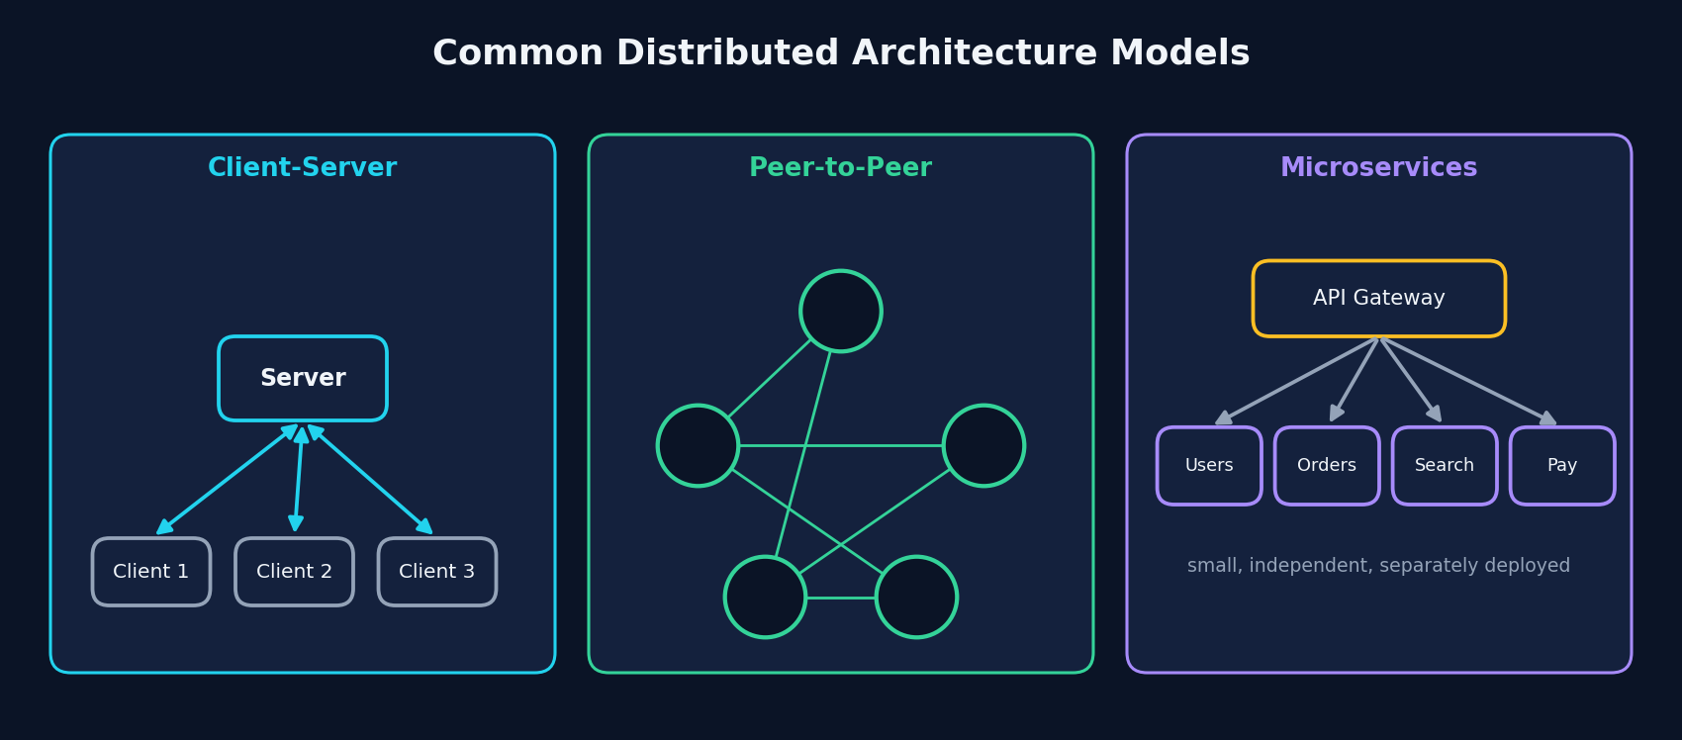
Figure 4: Common distributed architecture models

3.2 Core Concepts
- Replication: copies of data are stored on several nodes so the system survives failures and reads are faster.
- Partitioning / sharding: large data is split across nodes (shards) so no single node stores everything.
- Load balancing: requests are spread across nodes to avoid overload.
- Consensus: nodes agree on a single value or order of events (Paxos, Raft).
- CAP theorem: during a network partition a system must choose between consistency and availability.
- Fault tolerance: the system keeps working when some nodes or links fail.
- Eventual consistency: copies may be briefly different but converge to the same state.

3.3 Advantages and Disadvantages
Advantages | Disadvantages
- Scalability: add more machines to handle more load  - High availability: no single point of failure  - Fault tolerance through replication  - Resource sharing across locations  - Lower latency by placing servers near users  - Cost-effective with commodity hardware or cloud | - Complex to design, deploy and monitor  - Network latency and unreliable networks  - Partial failures are hard to detect and handle  - Keeping data consistent is difficult (CAP theorem)  - Security surface is larger (more nodes, more traffic)  - Debugging across many machines is hard

4. Real-Life Distributed Systems

4.1 Netflix: A Case Study
Netflix serves hundreds of millions of members around the world and is one of the best-known examples of a large-scale distributed system. Netflix moved away from a single monolithic data-centre application after a major database outage in 2008 and rebuilt on Amazon Web Services (AWS) using microservices.

Two cooperating parts
- Control plane (AWS): Everything that happens before you press play (sign-in, browsing, recommendations, billing, device management) runs on AWS as many independent microservices.
- Data plane (Open Connect CDN): The video itself is delivered by Netflix's own content delivery network, Open Connect, which places caching servers inside or close to internet service providers so video streams from a nearby machine.
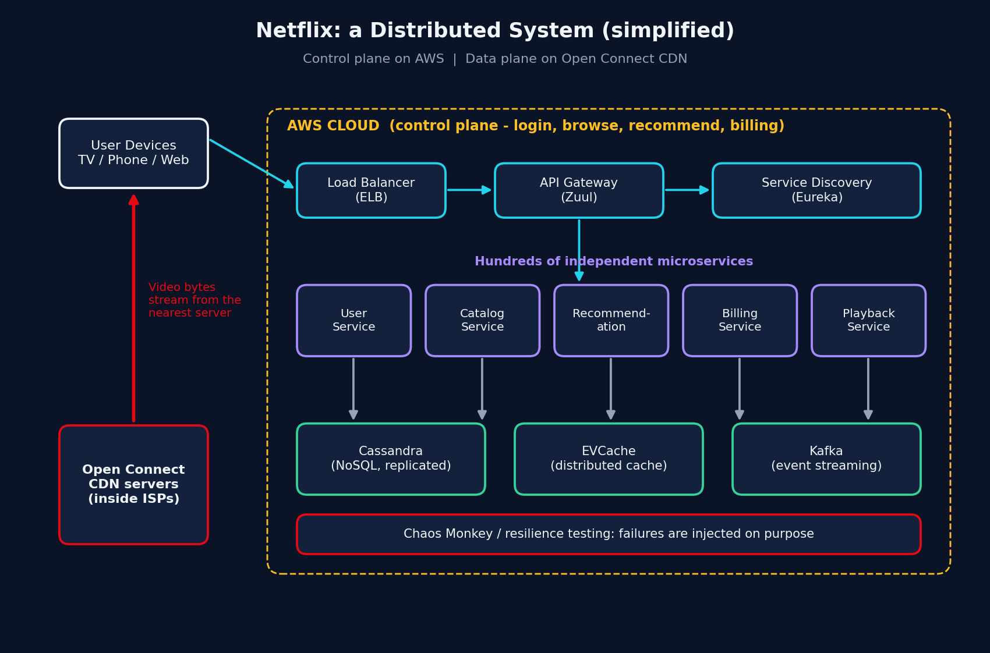
Figure 5: Simplified Netflix architecture (control plane on AWS, video delivery through Open Connect)

Distributed techniques Netflix uses
Technique | How it appears at Netflix
Microservices | The application is split into many small services (for example user, catalog, recommendations, playback) that are deployed and scaled independently.
API gateway (Zuul) | Client requests enter through a gateway that routes them to the right services.
Service discovery (Eureka) | Services find each other dynamically as instances start and stop.
Replicated NoSQL data (Cassandra) | Data is replicated across nodes and regions for availability and scale.
Distributed caching (EVCache) | Frequently used data is kept in memory close to the services to reduce latency.
Event streaming (Kafka) | Services publish and consume events such as viewing activity for recommendations and analytics.
CDN (Open Connect) | Popular titles are pre-positioned on servers near viewers to cut latency and backbone traffic.
Chaos engineering | Tools such as Chaos Monkey deliberately shut down instances so teams build software that survives failure.

Where parallel computing appears at Netflix
Netflix also relies on parallelism. Before a title can be streamed it is encoded into many formats and quality levels. The video can be split into chunks that are encoded in parallel on many machines and then stitched together, which turns a very long job into a much shorter one. Recommendation models are also trained with parallel and distributed machine learning. This shows that real systems combine both ideas.
Netflix in one line: microservices on AWS handle the logic, Open Connect handles the video, and everything is designed on the assumption that machines will fail.

4.2 Other Real-World Examples
System | What is distributed | Techniques used
Google Search | Web index and queries across huge clusters | MapReduce, Bigtable, Spanner, load balancing
Amazon (shopping and AWS) | Orders, inventory, storage and compute | Microservices, DynamoDB, replication, autoscaling
YouTube | Video storage and delivery worldwide | CDN, distributed storage, parallel transcoding
WhatsApp / messaging apps | Message routing for billions of users | Erlang-based servers, sharding, message queues
Bitcoin and blockchains | A ledger with no central owner | Peer-to-peer network, consensus (proof of work)
Uber and ride-hailing | Live location matching and pricing | Event streaming, geospatial sharding, microservices
Folding@home / BOINC | Volunteer computers solving science problems | Volunteer computing, work units split across PCs
Banking and payments | Transactions across branches and data centres | Replication, distributed transactions, consensus

5. Comparison and When to Use Each
Question | Prefer Parallel | Prefer Distributed
Is the goal raw speed on one big job? | Yes | Sometimes
Must the system stay up if a machine dies? | No | Yes
Does data need to live near users worldwide? | No | Yes
Does the job fit on one machine? | Yes | No
Is low communication delay critical? | Yes (shared memory) | Harder (network)
Need to scale by adding cheap machines? | Limited | Yes

In practice the two are combined. A cluster in the cloud (distributed) runs on machines with many cores and GPUs (parallel). Big-data tools such as Hadoop and Spark split work across machines and then across cores inside each machine.

5.1 Challenges Both Must Handle
- Race conditions and consistency: Two threads or two nodes updating the same data at once can corrupt it. Locks, transactions or consensus prevent this.
- Load balancing: Work must be divided evenly, otherwise fast workers wait for slow ones.
- Scalability limits: More parallel workers do not always mean proportionally more speed.
- Testing and debugging: Concurrent programs behave differently on every run, so testing needs special tools and techniques.

6. Conclusion
Parallel computing makes one task faster by running its parts at the same time, and distributed computing makes a system bigger, more reliable and closer to its users by spreading it across many machines. Parallel systems face the limit of Amdahl's Law and the difficulty of synchronization, while distributed systems face network delay, partial failure and consistency problems.
Real-world platforms such as Netflix, Google and Amazon show that the best results come from combining both: distributed microservices, replication and CDNs for scale and availability, plus parallel processing for encoding, analytics and machine learning. Understanding both models is essential for a software engineer designing modern, scalable software.

References
- Tanenbaum, A. S. and van Steen, M. Distributed Systems: Principles and Paradigms.
- Coulouris, G. et al. Distributed Systems: Concepts and Design.
- Dean, J. and Ghemawat, S. (2004). MapReduce: Simplified Data Processing on Large Clusters. OSDI.
- Amdahl, G. (1967). Validity of the single processor approach to achieving large scale computing capabilities.
- Netflix Technology Blog (netflixtechblog.com) and Netflix Open Connect documentation (openconnect.netflix.com).
- Grama, A. et al. Introduction to Parallel Computing.

